1. **Insights : Lead Source Distribution**

**Partner and website Collaborations:** Websites, Partners and Agencies generate substantial opportunities.

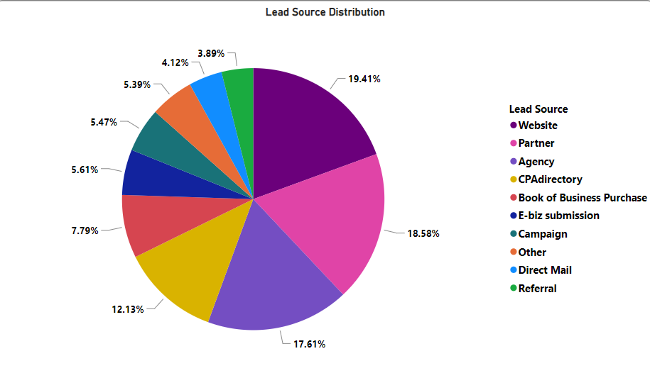

**2. Insights : Lead Source v/s Annual Revenue**

**Strategic Annual Revenue Opportunities:**

* Utilizing the website’s true potential can convert a lot of opportunities across all revenue slabs.
* On the higher revenue side we can improve our focus on agency and partner for converting opportunities.

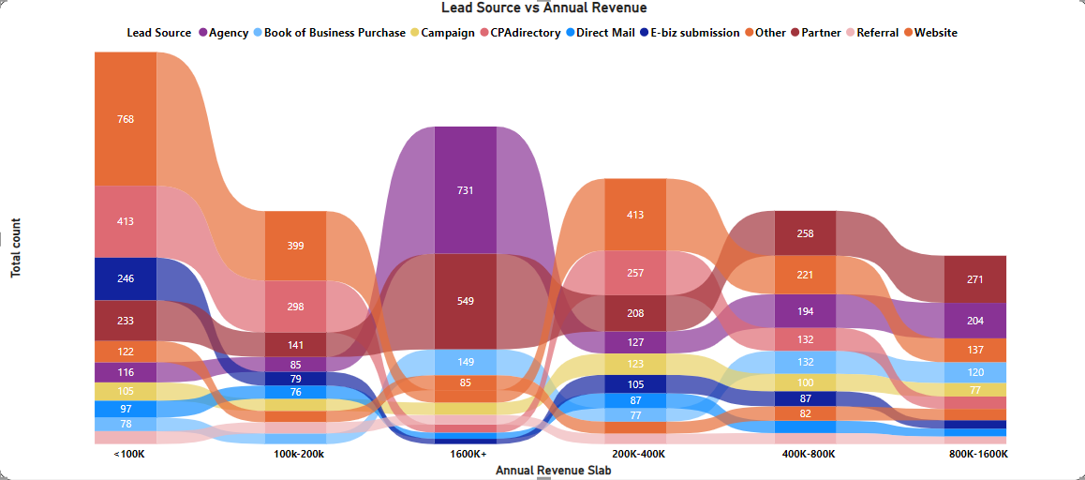

**3. Insights : HeatMap for Lead Source(X) vs Annual Revenue(Y)**

* Anticipate market trends for sustained high-conversion lead generation.
* Adapt Book of Business Purchase and Referrals strategies based on emerging dynamics.
* Predict shifts in CPAdirectory's conversion rates, ensuring lead source significance.
* Optimize conversions for higher annual revenue across all sources.
* Tailor agency approaches for improved high-revenue lead conversions.
* Enhance website tactics for converting lower revenue leads.
* Develop a predictive framework to maintain and improve conversions as revenue scales.

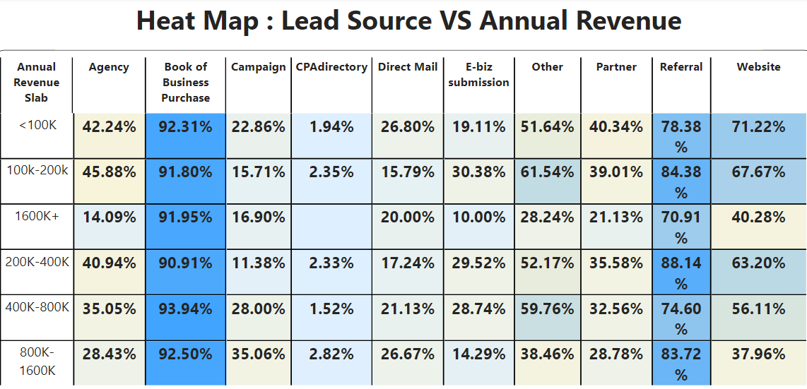

**4. Conversion Comparison in CA Cities**

* No significant variation or trend was observed in the Conversion Ratio across different cities.
* Across almost all cities, approximately 30%-40% of opportunities are successfully closed as 'won’.

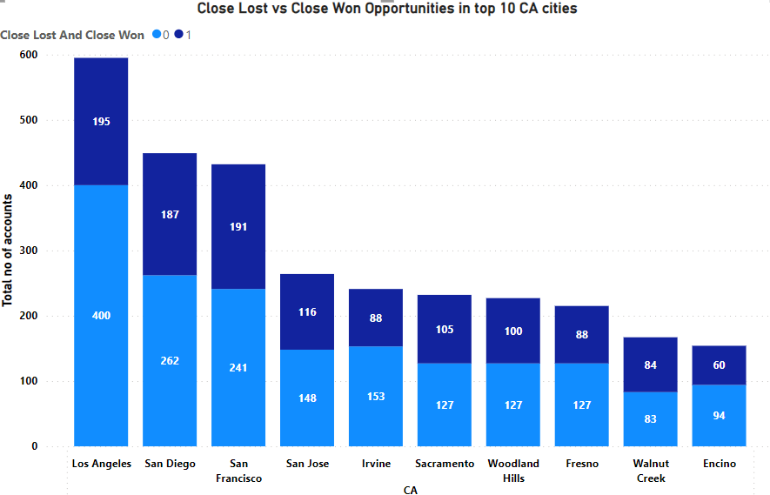

**5. Conversion Ratio v/s Number of Employees**

The changing scenario of the number of employees leads to a fluctuating conversion ratio.

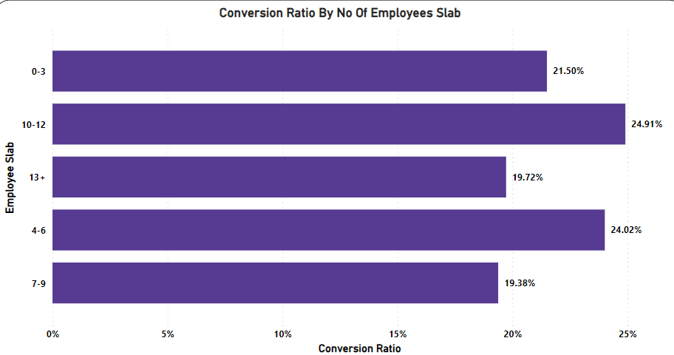

**6. Insights : Entity Type Distribution**

**Major business Contributors:** LLC, Sole Proprietor, S-Corporation

LLC, Sole Proprietor and S-Corporation has given a business boost and lead us to a lot of opportunities

A good strategic planning ensures effective positioning and engagement across LLCs, S-Corporations, Sole Proprietorships, and Corporations, maximizing opportunities in each business entity category.

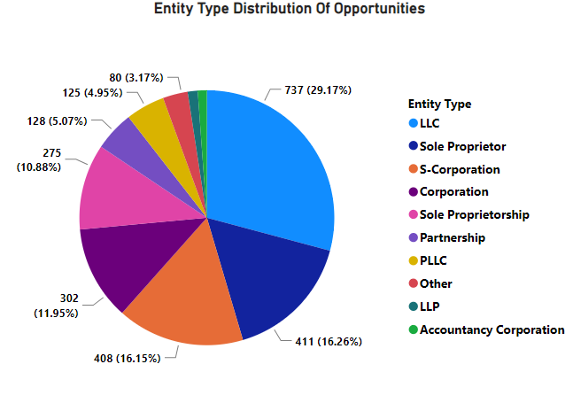

**7. Insights : Different entity types**

**Corporations' Impact Analysis:**

Corporations create lots of chances, but they don't always turn them into success. On the other hand, Sole Proprietors, PLLC, LLC are doing great. They not only grab opportunities but also turn them into wins. So entity types like Sole Proprietors , PLLC, S-Corporation convert a lot more opportunities by better planning and focusing.

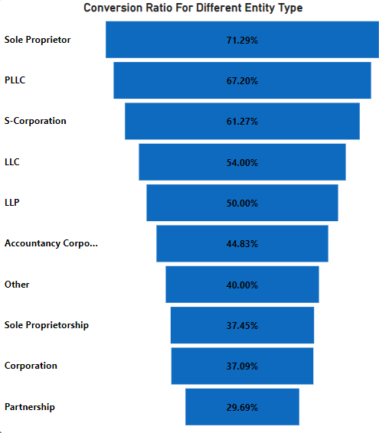

**8. Insights : Different business types**

Bare Firms and New Businesses significantly contribute to more generation but face a lower conversion rate.

Strategically tailoring conversion strategies for these segments is recommended to enhance overall sales effectiveness and optimize performance.

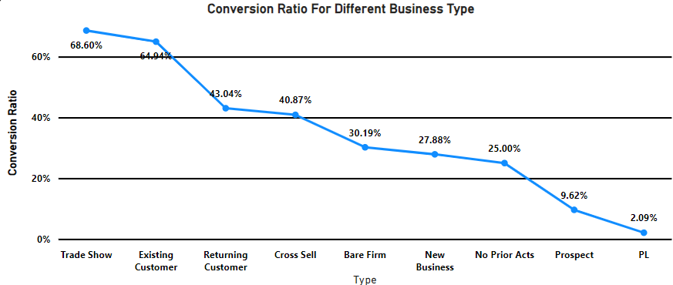

**9. Insights : New Businesses**

**Strategic Focus for Lead Generation and Conversion:**

* Prioritize high conversion ratio sources like Books of Business Purchases, Websites, and State Society.
* Optimize strategies for higher account number sources, including Agency, Partner, and CPAdirectory.
* Emphasize improving conversion rates by enhancing lead quality and refining sales approaches. Balancing this prioritization ensures a refined approach, optimizing overall effectiveness.

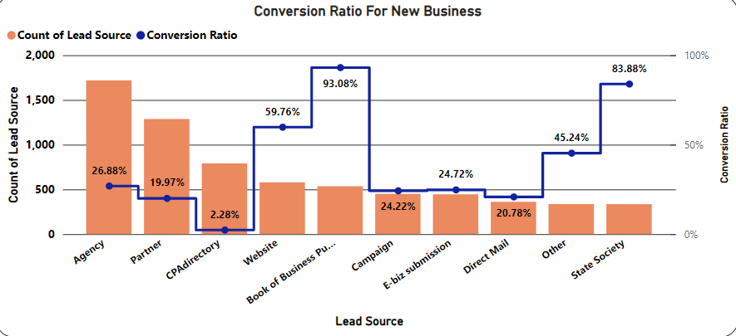

**10. Insights : Bare Firms**

**Evaluate performance metrics:** CPAdirectory, though with a lower conversion ratio, is the second-highest contributor; the Website leads in both contribution and conversion ratio.

Strategically, prioritize enhancing CPA directory's conversion rate while consistently maintaining and improving the Website's performance. A balanced approach ensures optimal overall sales effectiveness. Harmonizing efforts between optimization and performance is vital for success.

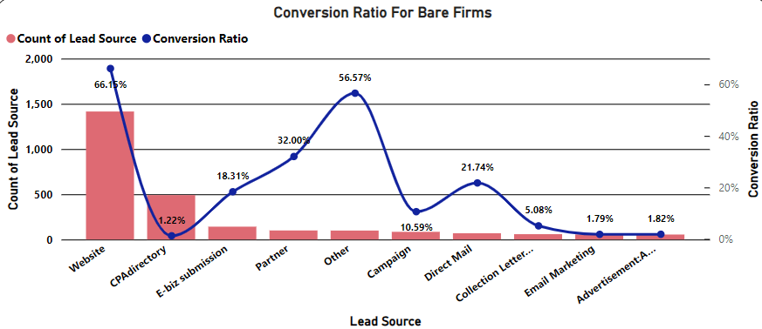

**11. Insights : Top 10 popular states**

**Focus on high-lead volume states:** California, Texas, and New York.

Direct sales efforts and formulate targeted strategies for these regions.

High potential for conversions, fostering substantial business growth.

Strategically align resources to enhance market presence in key geographical areas.

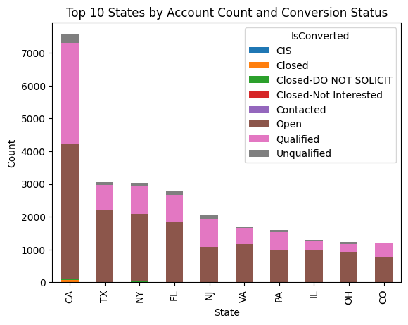

**12. Insights : Contact title v/s time**

**Lead Title Dynamics:**

* High contact volume for titles like Owner, Mr., President, Partner, and CPA.
* CEO, Managing Manager, and Sole Proprietor show higher conversion percentages, signaling successful closures.

**Time-Conversion Relationship:**

* Average lead conversion time: 174 days.
* Inverse relationship between time taken and conversion chances, emphasizing the need to optimize processes for quicker conversions and enhance overall sales outcomes.

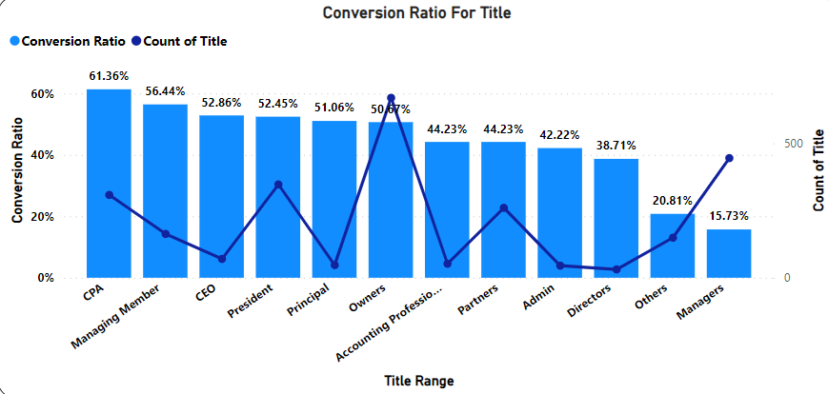

**13. Trends about annual revenue by business types**

The trend shows EP, cross sell and returning customers has a market dominance and are capable of converting higher revenue opportunities.

